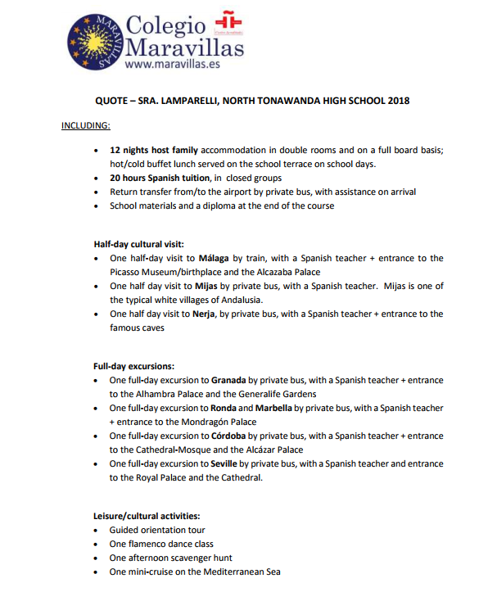

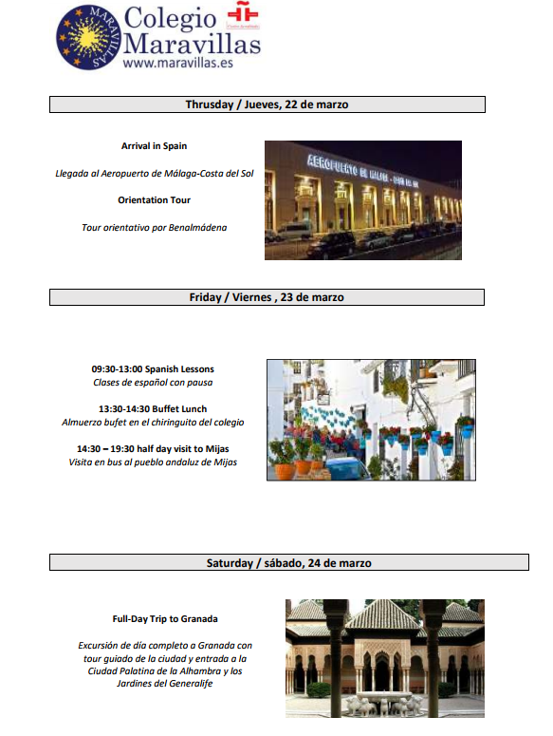

Baños árabes - $30-$50 per person – We will try to arrange appointments on Saturday, March 24.

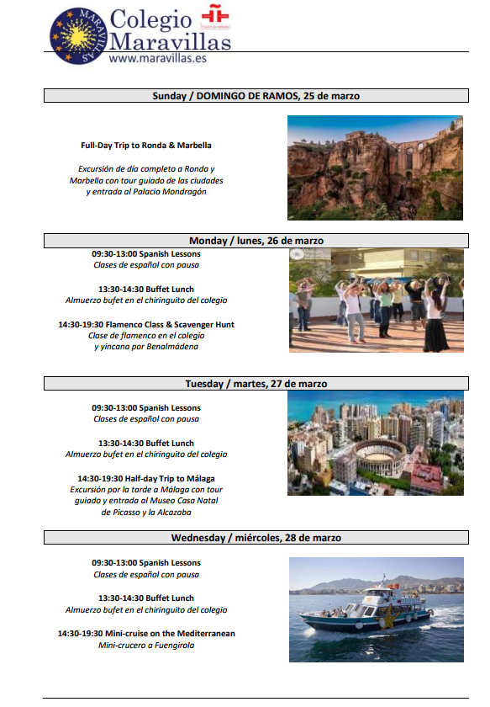

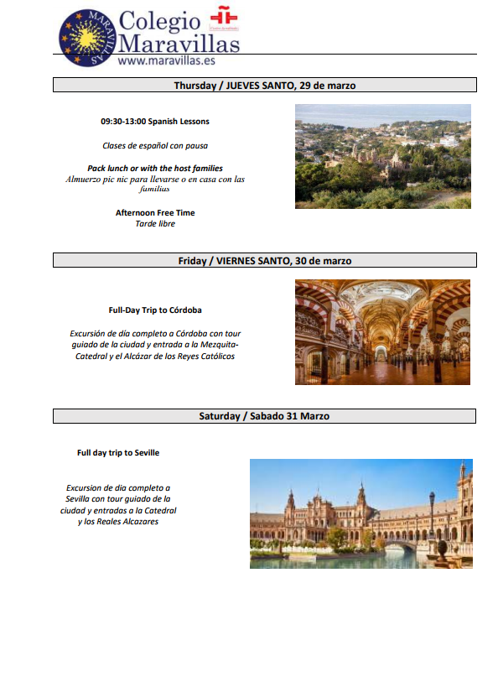

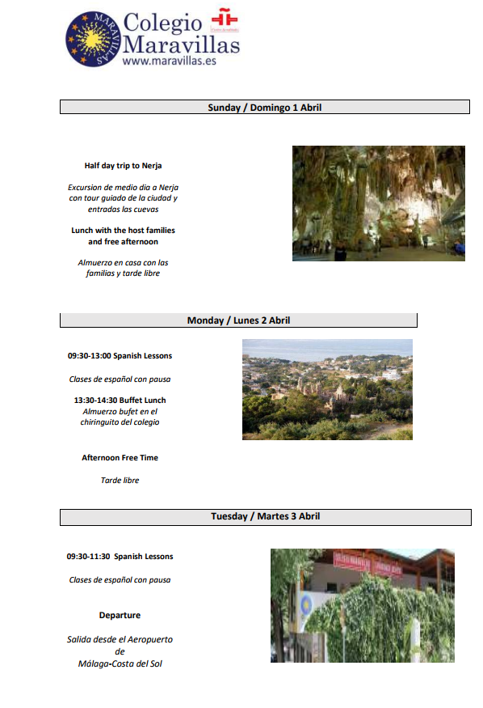

\*On the afternoon of April 1 (Easter Sunday) we will visit Monte Calamorro or the Acuario in Puerto Marina

\*Depending on scheduling, we may not have classes on April 3rd. Everyone will say good-bye to their host families and meet at the school. We have a 12:40 departure from Malaga to Montreal.